
Safety Bay Senior High School
Chemistry Unit 1 & 2

Test #1:
Stoichiometry

NAME: ______________________________________

Reading time: 5 minutes
Working time: 50 minutes

Section | Mark
Multiple Choice | / 5
Short Answer | / 45
Total | / 50

MULTIPLE CHOICE 5 marks
- If X₂O₃ is the correct formula for a metal oxide, the formula for the chloride of X is
  - XCℓ
  - XCℓ₂
  - XCℓ₃
  - X₃Cℓ₂

- Making use of the periodic table, the formula for francium oxide is most likely to be:
  - Fr₂O
  - FrO
  - Fr₂O₃
  - FrO₂

- A gas jar contains 6.022 x 10²⁴ molecules of carbon dioxide. How many moles of atoms is this?
  - 1
  - 3
  - 10
  - 30

- Ammonia gas reacts with oxygen gas according to the following equation:

4 NH₃(g) + 5 O₂(g) → 4 NO(g) + 6 H₂O(g)

Which of the following correctly calculates the number of moles water produced from 7.80 moles of ammonia?
Note: The relative molecular mass of ammonia is 45.054 and the relative molecular mass of water is 18.016.
(a) | 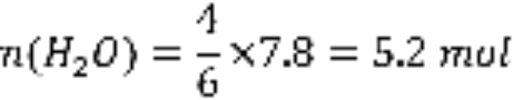
(b) | 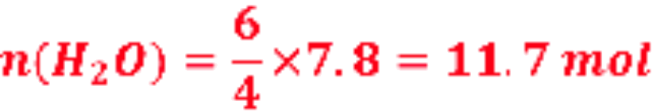
(c) | 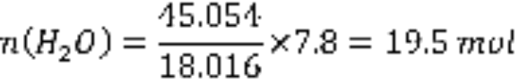
(d) | 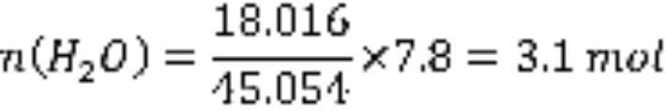

- What values of w, x, y and z are required to balance the following equation?
w Aℓ + x H₂O → y Aℓ₂O₃ + z H₂
  - w = 2 x = 3 y = 1 z = 3
  - w = 2 x = 4 y = 2 z = 6
  - w = 1 x = 3 y = 1 z = 3
  - w = 3 x = 4 y = 1 z = 6
SHORT ANSWER 45 marks
- (3 marks)

Complete the table by writing the formula for each ion. (½ mark each)
Ion name | Ion formula
Aluminium ion | Aℓ³⁺
Iodide ion | I⁻
Strontium ion | Sr²⁺
Nitrate ion | NO³⁻
Hydrogensulfate ion | HSO₄⁻
Sulfite ion | SO₃²⁻

Answer | Marks
See table above | 6 x 0.5 marks
Total marks: | 3 marks

- (8 marks)

- Write the formulas of the following compounds:

Answer | Marks
- CaCO₃ | 1 mark
- HNO₃ | 1 mark
- PbI₂ | 1 mark
- CuCl₂•2H₂O | 1 mark
Total marks: | 4 marks

- Write the names of the following compounds:

Answer | Marks
- Acetic acid OR ethanoic acid | 1 mark
- Diphosphorus tetraiodide (NOT tetraiodine) | 1 mark
- Chromium(III) bromide (NOT bromine. Must include oxidation state) | 1 mark
- Barium hydroxide | 1 mark
Total marks: | 4 marks

- (1 mark)

Give a definition for the term relative molecular mass.

Answer | Marks
The mass (of a molecule) relative to 1/12th of a carbon-12 atom | 1 mark
Total marks: | 1 mark

- (3 marks)

Complete the table below to show the symbols used to represent various measurements in chemistry and the units in which they are measured. The first line has been done as an example.
Measurement | Symbol | Units
Mass | m | g
Number of moles | n | mol
Molar mass | M | g mol⁻¹ (or g/mol)
Relative molecular mass | M_{r} | “Unitless” or “None”

Answer | Marks
See table above | 6 x 0.5 marks
Total marks: | 3 marks

- (2 marks)

Calculate the molar mass of the following substances.

- Ammonium nitride, (NH₄)₃N (1 mark)

Answer | Marks
68.136 g mol⁻¹ | 1 mark
Deduct 0.5 marks if missing or incorrect units | -
Total marks: | 1 mark

- Cobalt(II) chloride hexahydrate, CoCℓ₂•6H₂O (1 mark)

Answer | Marks
237.926 g mol⁻¹ | 1 mark
Deduct 0.5 marks if missing or incorrect units | -
Total marks: | 1 mark

- (2 marks)

Calculate the number of moles of magnesium atoms in:

- 70.0 g of magnesium metal (1 mark)

Answer | Marks
n(Mg) = m / M = 70 / 24.31 = 2.88 mol | 1 mark
Deduct 0.5 marks if missing or incorrect units | -
Total marks: | 1 mark

- 0.568 mol of magnesium phosphate, Mg₃(PO₄)₂ (1 mark)

Answer | Marks
n(Mg) = 3 x n(Mg₃(PO₄)₂) = 1.70 mol | 1 mark
Deduct 0.5 marks if missing or incorrect units | -
Total marks: | 1 mark

- (3 marks)

Calculate, to three significant figures, the number of water molecules in a 200 mL glass of water.
(Note: 1 mL of water has a mass of 1 g)

Answer | Marks
n(H₂O) = m / M = 200 / 18.016 = 11.10 mol | 1 mark
N(H₂O) = n x 6.022 x 10²³ = 66.9 x 10²³ (or 6.69 x 10²⁴) | 1 mark
Answer is given to three significant figures | 1 mark
Total marks: | 3 marks

- (5 marks)

Arsenic-containing compounds have high levels of toxicity. It was widely used as a poison in the middle ages due to its lack of colour and odour and because its symptoms mirrored food poisoning or other disorders.

- One common form of arsenic used as a poison in the Roman Empire was arsenic trioxide (As₂O₃). Calculate the percentage by mass of arsenic in this compound. (2 marks)

Answer | Marks
M(As₂O₃) = 197.84 g mol⁻¹ | 1 mark
%As = 2 x M(As) / M(As₂O₃) x 100 = 149.84 / 197.84 x 100 = 75.7% | 1 mark
Total marks: | 2 marks

- Arsenic poisoning can be deadly above levels of 11 mg of arsenic per 1 kg of body mass. What mass of arsenic would be required to kill a person with a body mass of 80 kg? (1 mark)

Answer | Marks
11 mg/kg x 80 kg = 880 mg (or 0.880 g) | 1 mark
No marks if no units are included | -
Total marks: | 1 mark

- Calculate the mass of arsenic trioxide (in mg) which would be required to deliver the dose of arsenic calculated in part (b). (2 marks)

Answer | Marks
m(As) = m(As₂O₃) x 75.7%  Therefore m(As₂O₃) = m(As) / 75.7% = 1160 mg | 1 mark
Answer is in mg  (Award only 1 mark for an answer of 1.16 g) | 1 mark
Total marks: | 2 marks

- (7 marks)

An organic compound was known to contain the elements carbon, hydrogen and oxygen only. Combustion of the organic compound produced carbon dioxide and water, and from the masses of these respective products it was determined the compound consisted of 40.0% carbon and 6.67% hydrogen.

- From the data provided, calculate the empirical formula of the compound. You must clearly show all working. (5 marks)

 | C | H | O
Mass (g) | 40.0 | 6.67 | 53.33
Moles (mol) | 3.33 | 6.62 | 3.33
Mole ratio | 1 | 2 | 1
Empirical formula is CH₂O

Answer | Marks
Converts percentages to masses and calculates m(O) | 1 mark
Calculates moles of C, H and O | 1-2 marks
Calculates mole ratio | 1 mark
Writes empirical formula in the form of CH₂O | 1 mark
Total marks: | 5 marks

- Mass spectrometry revealed that the same organic compound had a relative molecular mass of approximately 180. Suggest a molecular formula for this compound and explain how you came to this conclusion. (2 marks)

Answer | Marks
Molecular formula is C₆H₁₂O₆ | 1 mark
For the explanation student must show a logical reason why this is the correct formula.  The following should be included in their reason:  - C₆H₁₂O₆ is a multiple of the empirical formula, AND  - C₆H₁₂O₆ has a relative molecular mass of 180.  Their reasoning should explicitly recognise the link between their given molecular formula and the empirical formula from the previous question. i.e. their reason cannot just be “because C₆H₁₂O₆ has a relative molecular mass of 180” – it needs more than that.  Note: Given that students have probably not been formally taught to calculate MFW/EFW, do not penalise students who tackle this problem with a guess and check approach. The reasoning does not need to include MFW/EFW calculation, although students showing this working should be awarded full marks for reasoning. | 1-2 marks
Total marks: | 3 marks

- (5 marks)

One type of fire extinguisher depends on the reaction of sodium hydrogencarbonate with sulfuric acid to produce a salt, water and carbon dioxide. The equation for the reaction is:

2 NaHCO₃ + H₂SO₄ → Na₂SO₄ + 2 H₂O + 2 CO₂

(a) Write the name of the salt formed in this reaction. (1 mark)

Answer | Marks
Sodium sulfate | 1 mark
Total marks: | 1 mark

(b) Calculate the number of moles of NaHCO₃ in 500 g of sodium hydrogencarbonate. (2 marks)

Answer | Marks
M(NaHCO₃) = 84.008 g mol⁻¹ (can be shown as part of n=m/M equation) | 1 mark
n(NaHCO₃) = m / M = 500 / 84.008 = 5.95 mol | 1 mark
Deduct 0.5 marks if missing or incorrect units | -
Total marks: | 2 marks

(c) What mass of sulfuric acid would be required to react completely with 500 g of sodium hydrogencarbonate? Give your answer to three significant figures. (2 marks)

Answer | Marks
n(H₂SO₄) = 0.5 x n(NaHCO₃) = 2.98 mol | 1 mark
m(H₂SO₄) = n x M = 2.98 x 98.086 = 292 g | 1 mark
Total marks: | 2 marks

- (5 marks)
(a) Metallic iron can be produced from the reaction of iron(III) oxide with carbon monoxide, with carbon dioxide gas produced as a by-product. Complete the balanced equation by writing the chemical formula for each substance in the boxes. (1 mark)

1 | Fe₂O₃ | + 3 | CO | → 2 | Fe | + 3 | CO₂
 | Iron(III) oxide |  | Carbon monoxide |  | Iron |  | Carbon dioxide
Answer |  |  |  |  |  |  |  | Marks
ALL boxes have the correct formula |  |  |  |  |  |  |  | 1 mark
Total marks: |  |  |  |  |  |  |  | 1 mark

(b) What mass of iron(III) oxide would be required to produce 160 kg of metallic iron? Clearly show all working. (4 marks)

Answer | Marks
Converts 160 kg into grams for mole calculations (must be evident from working) | 1 mark
n(Fe) = m / M = 160 000 / 55.85 = 2865 mol (must be explicitly shown) | 1 mark
n(Fe₂O₃) = 0.5 x n(Fe) = 1432 mol (must be explicitly shown) | 1 mark
m(Fe₂O₃) = n x M = 1432 x 159.7 = 228756 g = 229 kg | 1 mark
Note: Can also be calculated using percentage composition.  e.g. m(Fe₂O₃) = m(Fe) / %Fe | -
Total marks: | 4 marks

